History – Year 4 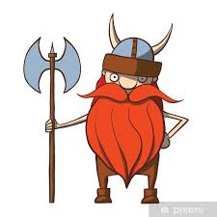

Create your own timeline showing what happened between AD 410 and AD 1066. You can write the events or draw pictures.  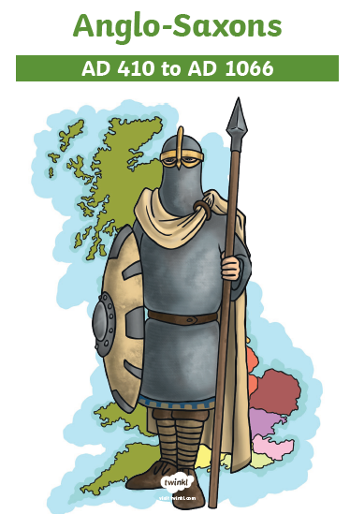 | Who were the Vikings?  Create a poster to explain key facts about them. Your poster must include the word ‘invade.’ | Write a persuasive letter to the Vikings to convince them not to invade Britain. Use the mats to help you.  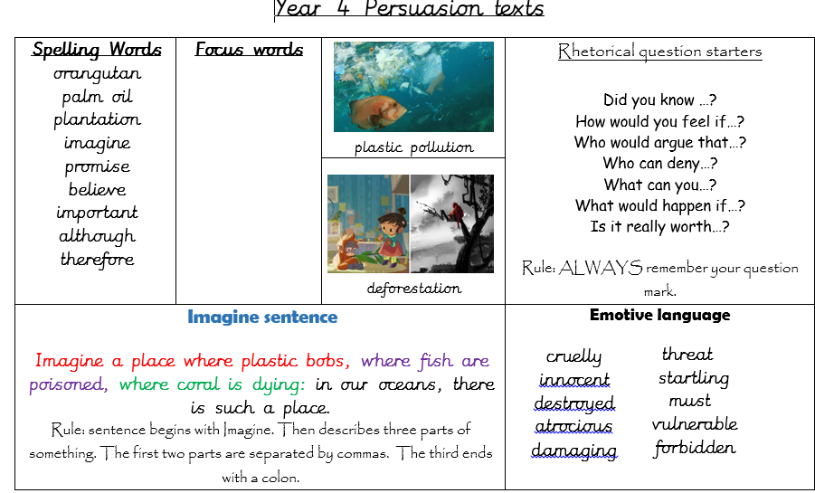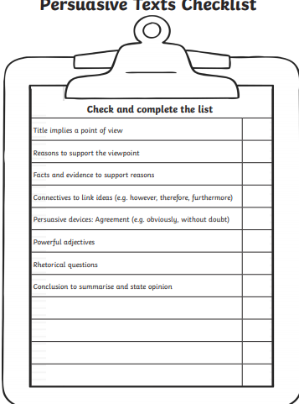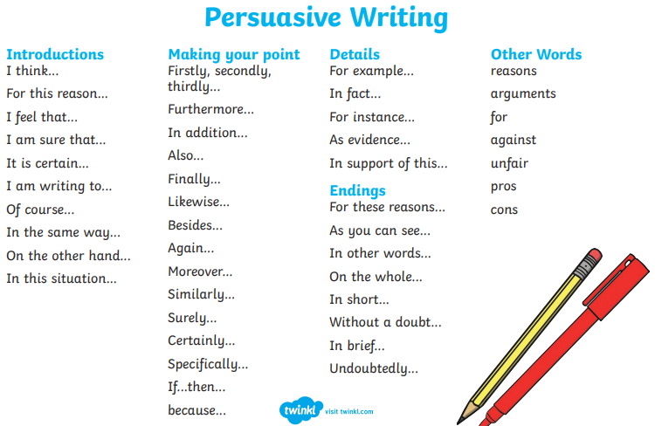 | Create a 3D model of a Viking Long Ship using whatever materials you can find.
Create your own Viking God or Goddess. Think about what they are called, what they might represent, how they might dress and anything they might have with them. | Spell your name using the Anglo Saxon alphabet. Use the rune for the first letter of your name and create a piece of art around it.  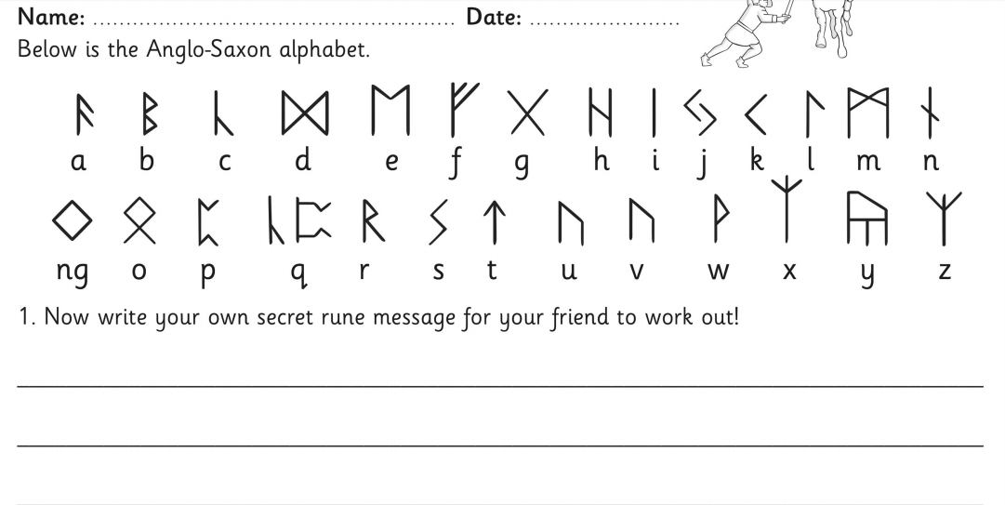 | Write a diary entry as your Viking God or Goddess. What have they done today? | Create a comic strip to show the cause and what happened at the Battle of Hastings (1066)
Create a fact file about King Alfred the Great.  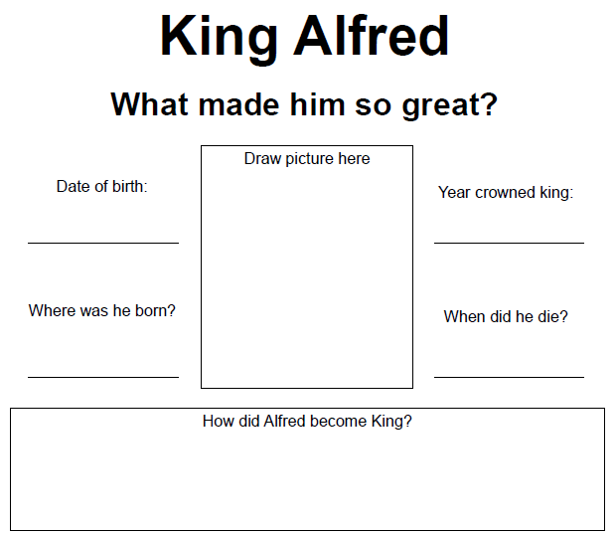 | Draw yourself as a Viking or and Anglo Saxon. Think about what you would have worn, what your hair might have looked like and what weapons you may have had. | Create your own Anglo Saxon Brooch design | Create a poster for a typical job in an Anglo Saxon village. Think about what sort of skills people would need.

